# Context

* Theme: Entertainment
* Persona: Caring Grandmother Anita

## Empathize

Our persona is Grandmother Anita who has a diploma and was recently working. She quit her job, as it was time consuming, so that she can spend more time with her loving and growing family. Her ambitions are to take care of her grandchildren and traveling around the world. She is not comfortable with technology and is not familiar with the industry specific terms. She keeps a scrapbook with all her travels and would like to make more loving memories with her family while traveling. Anita uses social media for sharing her experiences and wants to have a platform where she can share her adventures. Finding ideas for travels is also an interest that she would like to expand and have more options in the future. She is a free and open-minded lady looking for new adventures to fill up her free time.

## Empathy Map

## Moodboard

## Research & Brainstorming Session

Hereby a list of the brainstormed app ideas we’ve made for Anita. Underneath are some worked out concepts that we went through:

**Adventure book app:**

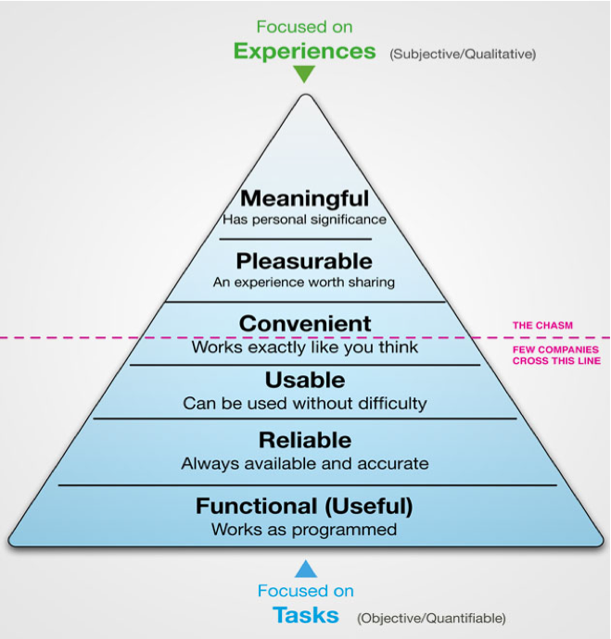 The app we came up with is an app that gives you adventures, depending on the type you’d like to do. We will give the user the opportunity to do adventures outside with children or alone. After you take the adventure, you will have the option to add a photo of the adventure, write a short memory of the adventure.

This will give the user the chance to do an activity depending on if they want to do it indoors or outdoors. This is a great idea-maker for people that have a lot of free time or struggle to decide on what activities to do.

There will be how much time roughly it would take for the user to finish this adventure, the “filters” we would be using to make you choose what type of adventure will be shown in the start and an icon will show what type of adventure you have chosen. The user will be able to see past adventures in their profile.

Competitors:

* The concept exists in book format
* No further apps could be found on the App Store

1. A picture containing website

   Description automatically generatedUser Scenario

# Sketches

# Icon Description automatically generatedPrototype

# Testing

# Conclusion